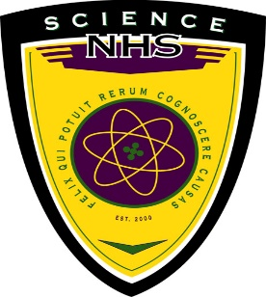**Lincoln High School**

**Science National Honor Society**

Science National Honor Society (SNHS) is a national organization honoring and encouraging student excellence in science. Institutions nation-wide recognize SNHS members as scientific leaders in their high school and community.

The SNHS was established in year 2000 with a goal to create a new group of young thinkers who will be the future of industry, research, and scientific exploration. With those objectives in mind and to celebrate the excellence that our students have regularly pursued in their science coursework, we submitted the application to the High School Science National Honor Society in 2018 and we were granted a charter for chapter 1366. In this era of rapidly changing technologies and scientific advancement, it is time to encourage more and more students to take interest in science and pursue careers in science related fields.

**The objectives of the SNHS are:**

* Encouraging and recognizing scientific and intellectual thought
* Advancing students’ knowledge of classical and modern science
* Communicating with the scientific community
* Aiding the civic community with its comprehension of science

**To be eligible for membership, potential applicant must:**

* be a junior or senior
* have 85 or higher average across all sciences
* have at least an 80 cumulative GPA
* currently be enrolled in a science course
* have taken at least one CH science course
* is currently taking an AP course or plans to take during senior year

**To maintain membership in the SNHS, an inductee must**

* continue to achieve 85 or higher average across all sciences
* continue to achieve at least an 80 cumulative GPA
* take a CH science course or AP science course in the senior year
* score 80 or higher on at least one science Regents Exam
* regularly attend monthly Science National Honor Society meetings
* complete 10 hours of community service or peer tutoring
* either be enrolled in a science research class or work independently on a research paper and present it during our monthly SNHS meetings.